AI ASSISTED CODING
Exploring Additional AI Coding Tools beyond Copilot – Gemini (Colab)
and Cursor AI

LAB-2
NAME: P. MANVITH
ROLL NO : 2503A52378
BATCH: 13

- AI TOOL USED : VS CODE
PROMT: #generate a code to find least common multiple (LCM) of two numbers

INPUT:
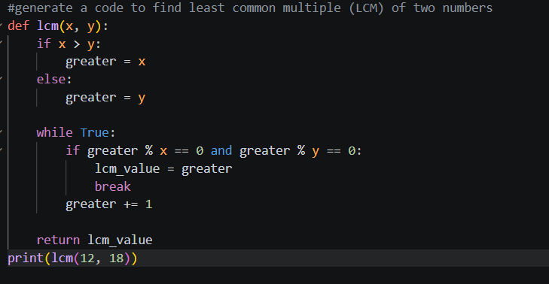

OUTPUT: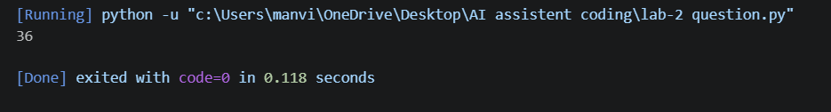

2.AI TOOL USED : GOOGLE COLAB
PROMT: #generate a code to find least common multiple (LCM) of two numbers

INPUT :

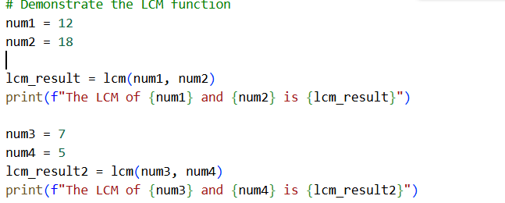

OUTPUT:



3.AI TOOL USED : CHATGPT
PROMT: #generate a code to find least common multiple (LCM) of two numbers
INPUT :
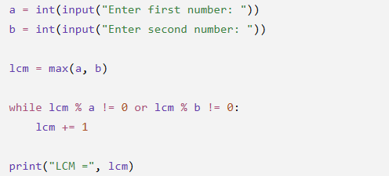

OUTPUT:
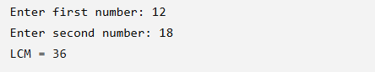

Comparison
The 1st code uses a function and is reusable, while the 2nd code uses the same function with multiple examples for demonstration.
The 3rd code does not use a function and directly takes input from the user, making it shorter and simpler.
Therefore, the 3rd code is the easiest for beginners, while the 1st and 2nd are better for understanding functions and reusable code.
CONCLUSION:
The 3rd code is the easiest and most beginner-friendly because it is simple and directly takes user input.
The 1st and 2nd codes are better for understanding functions and writing reusable programs.

